STARAGILE JENKINS ASSIGNMENT-1

**Step 1: Setup Jenkins on AWS Ubuntu Machine**

1. SSH into your AWS Ubuntu instance.
2. Install Java:

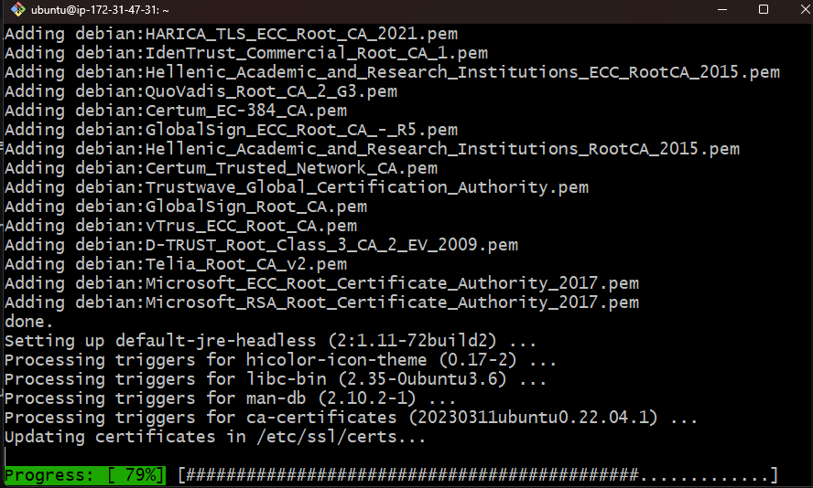

1. Install Jenkins:

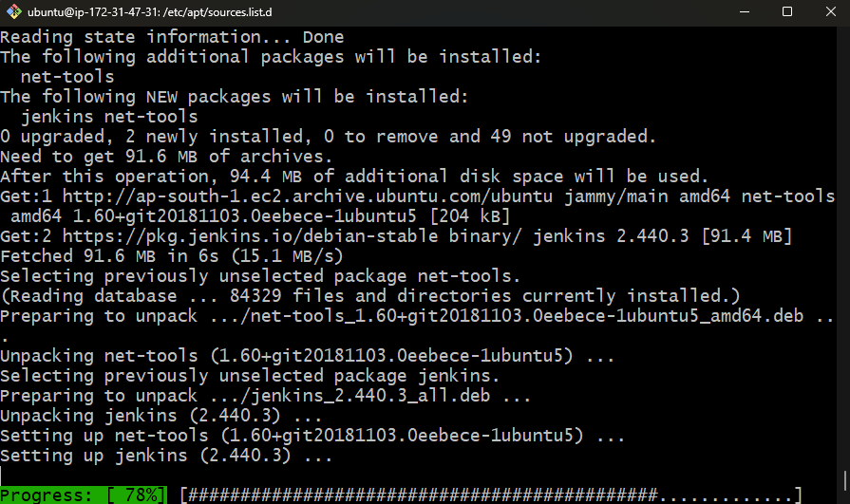

1. Start Jenkins:

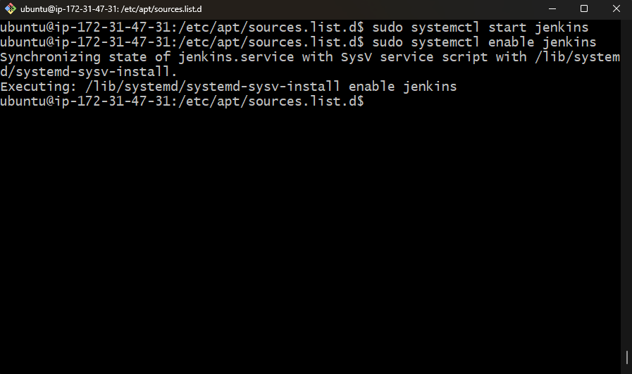

Open 8080 port from aws console  
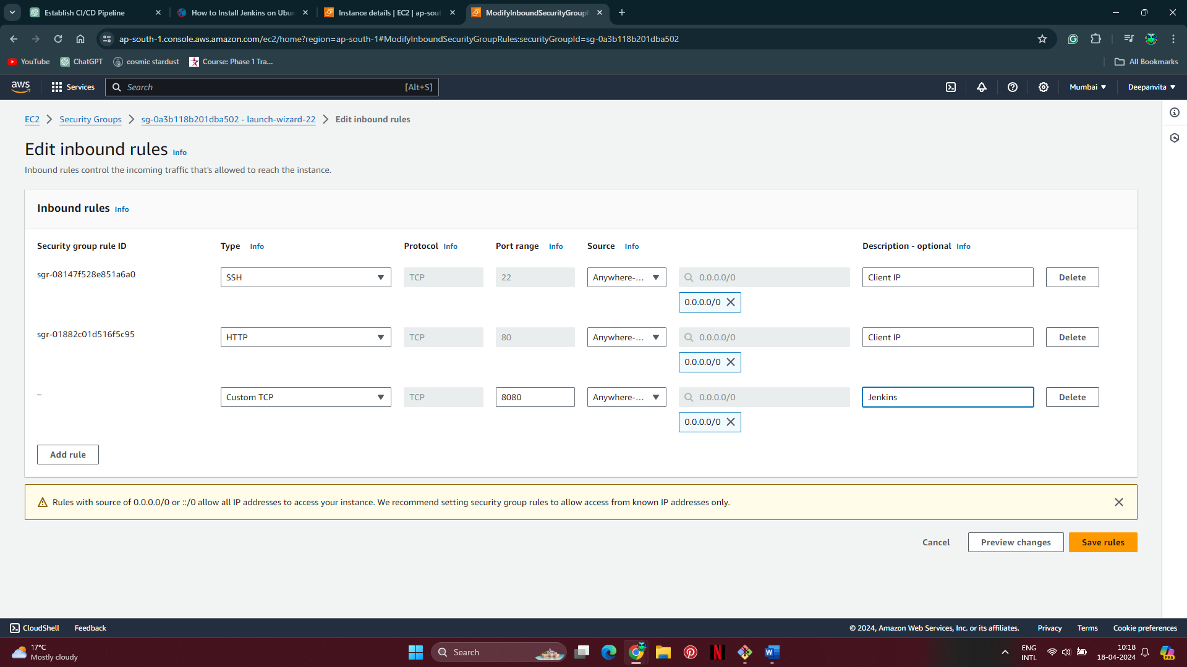

1. Access Jenkins using your instance's public IP address and port 8080 in a web browser.

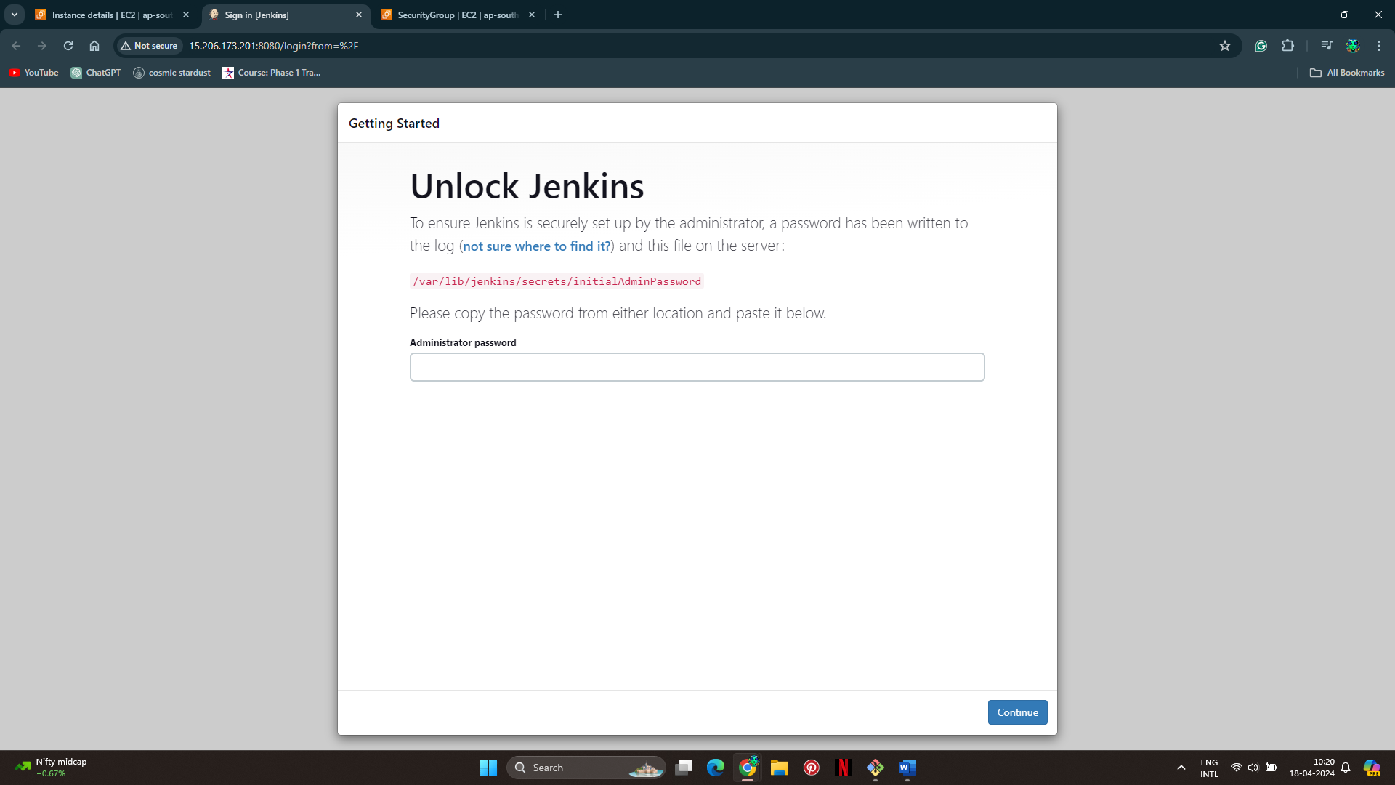

**Step 2: Create a Freestyle Project**

1. In Jenkins dashboard, click on "New Item".

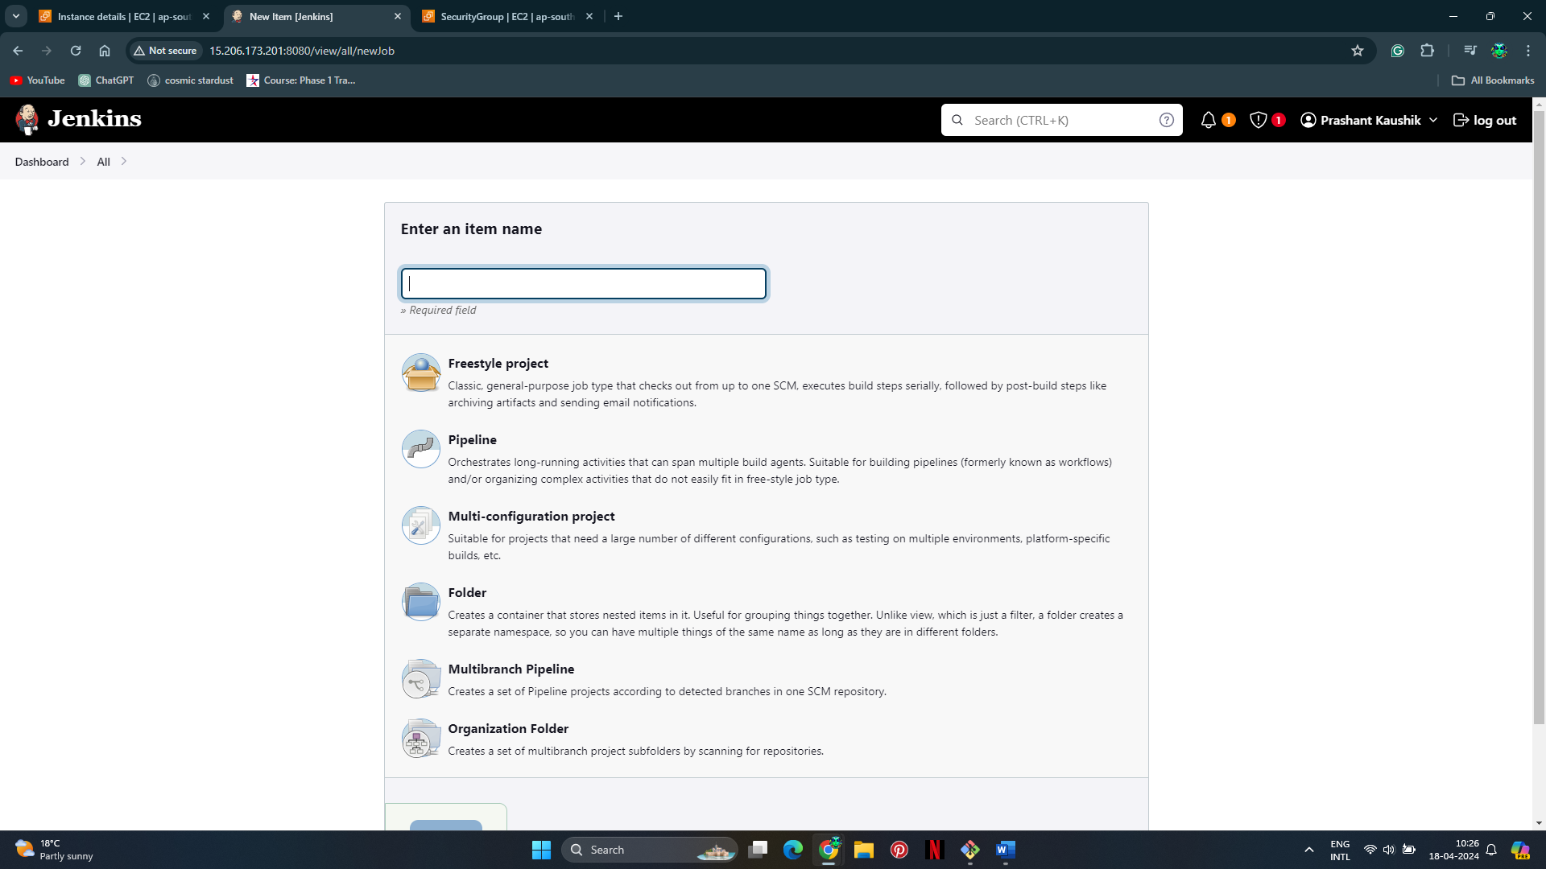

1. Enter a name for project, select "Freestyle project", and click "OK".

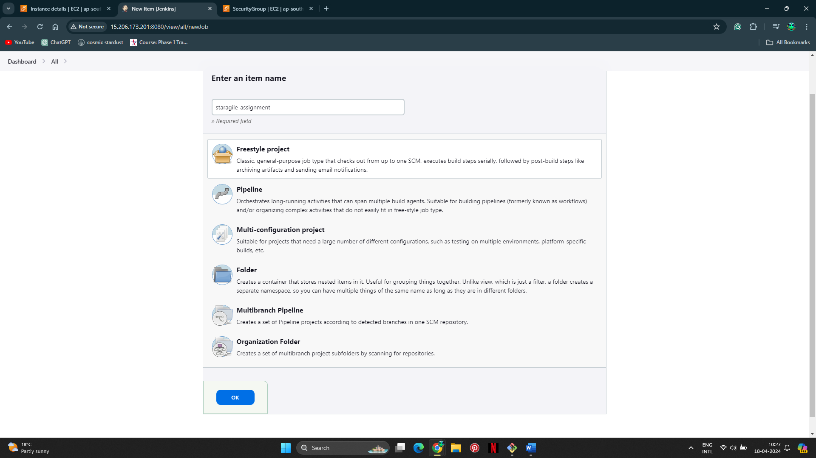

**Step 3: Configure Git Repository for Code Checkout**

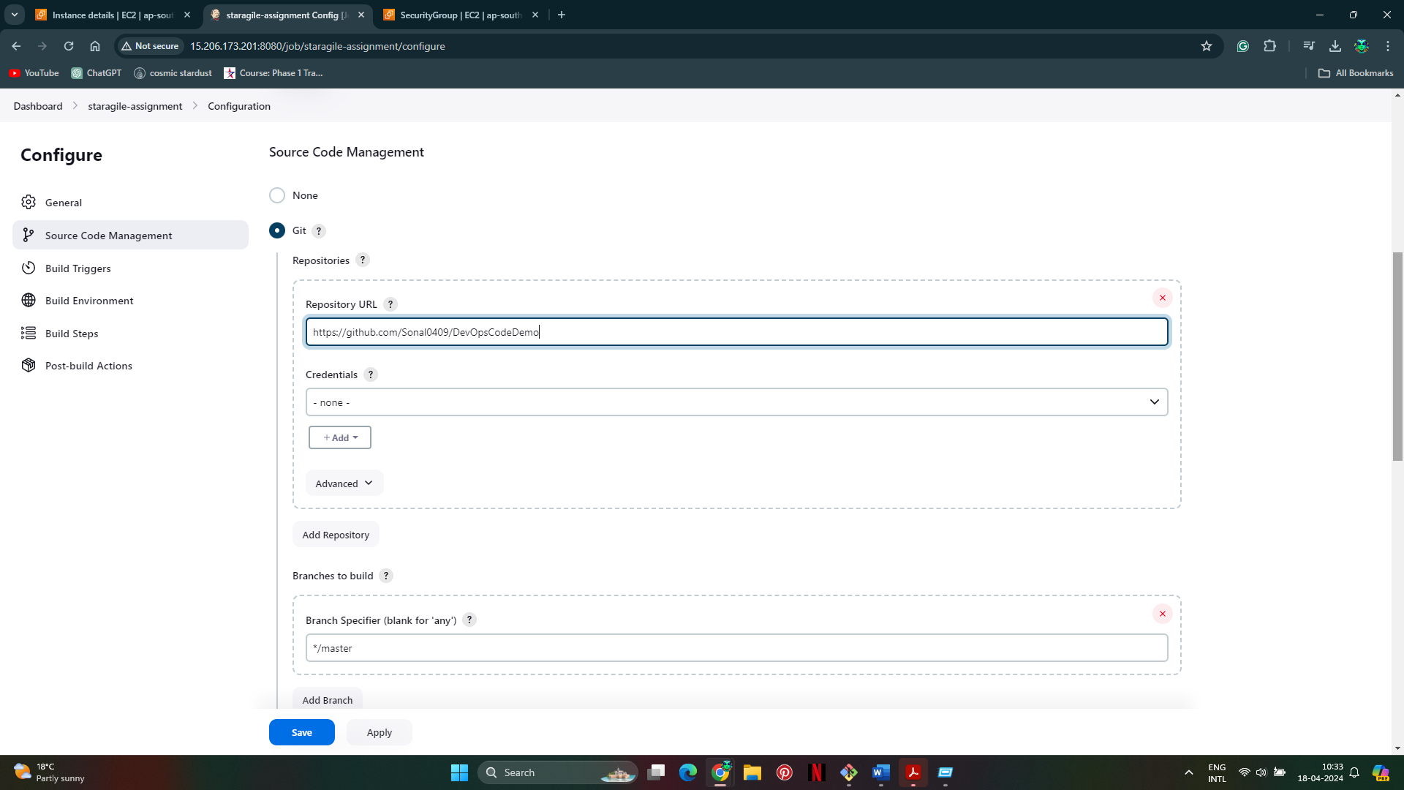

**Step 4: Compile Source Code Using Maven**

1. In the project configuration, under "Build", click on "Add build step" and select "Invoke top-level Maven targets".
2. Enter the Maven goals like **clean install**.

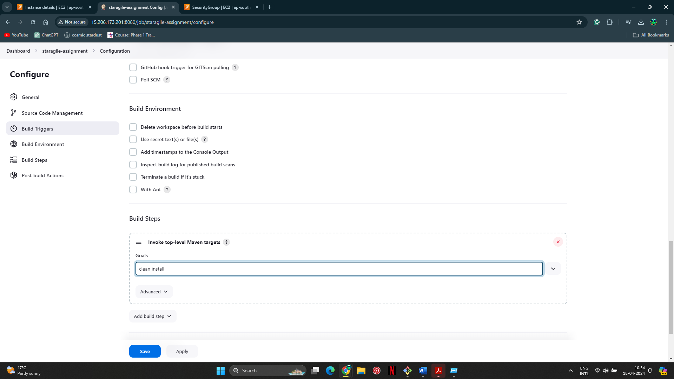

**Step 5: Execute JUnit Test Cases Using Maven**

1. Add another build step of type "Invoke top-level Maven targets".
2. Enter the Maven goals like **test**.

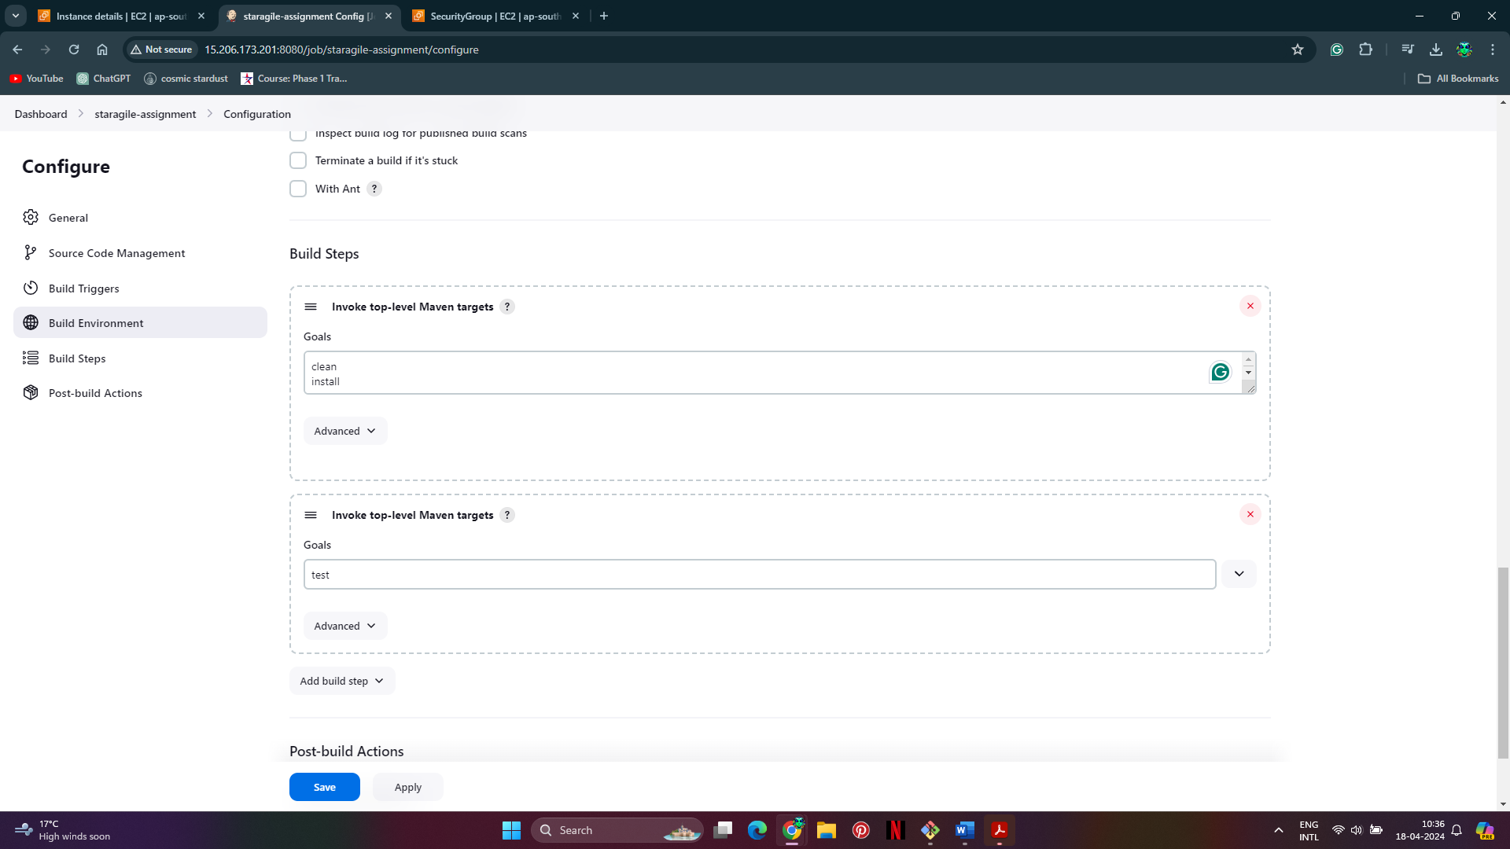

**Step 6: Package Application as War**

1. Add another build step of type "Invoke top-level Maven targets".
2. Enter the Maven goals like **package**.

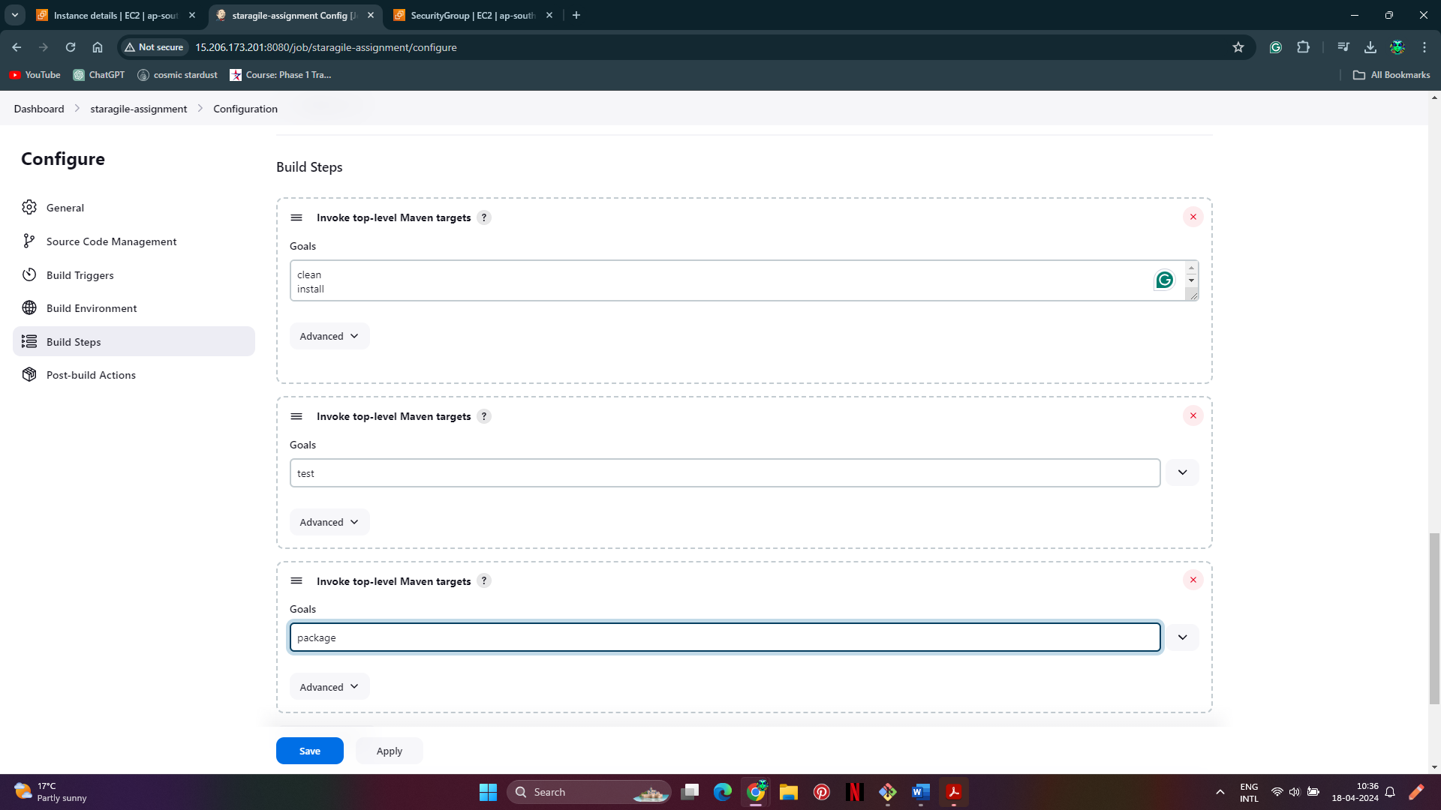

**Step 7: Install Tomcat9 Server on AWS Ubuntu Machine**

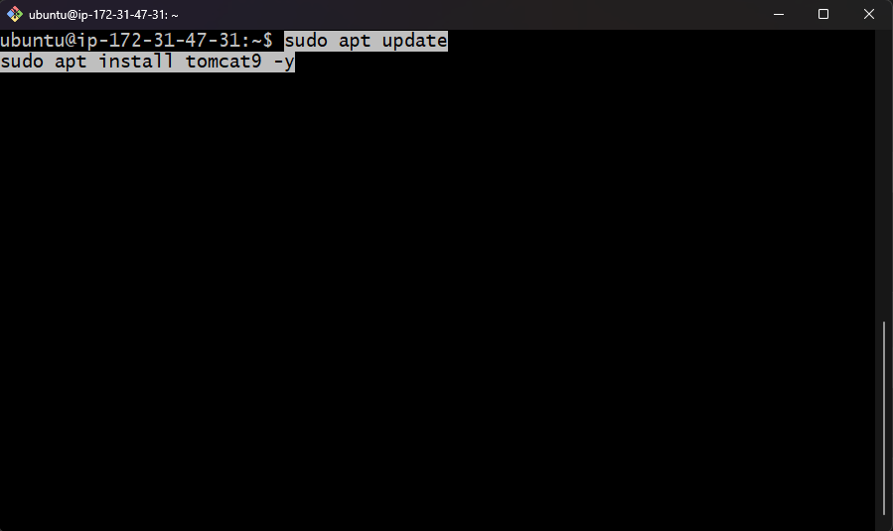

Start Tomcat:



**Step 8. Deploy the packaged application on Tomcat9**.

Install deploy to container plugin

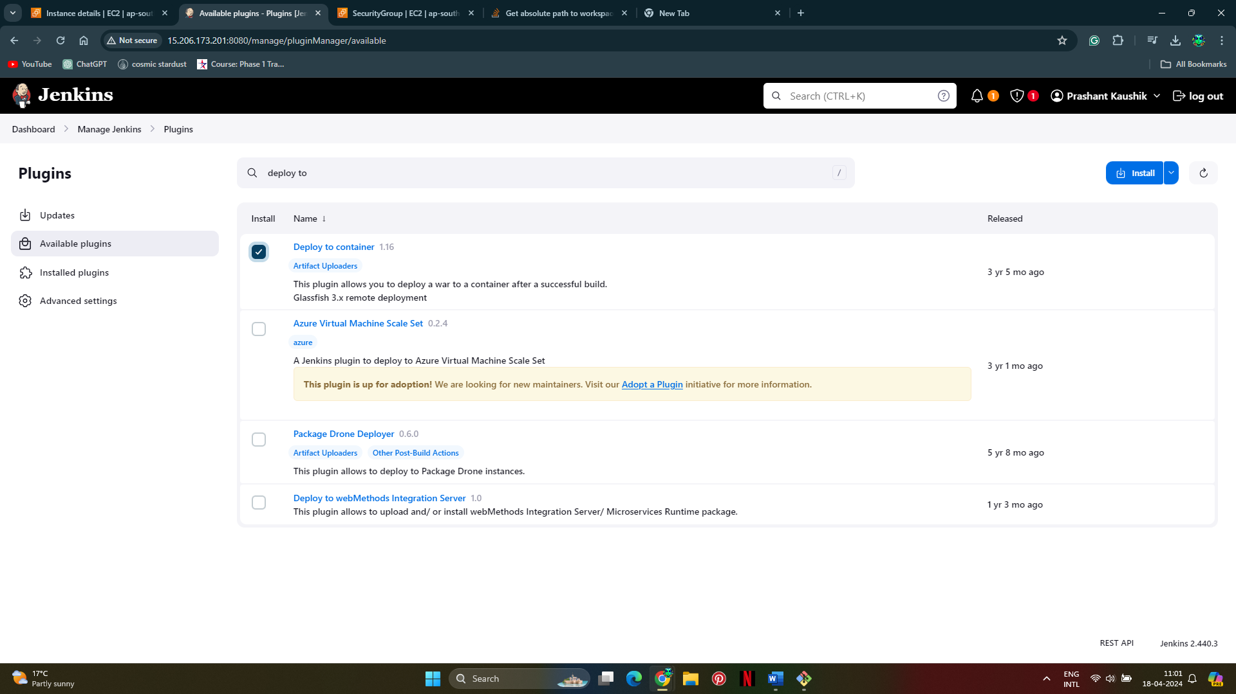

**Step 9. Setup post build actions**

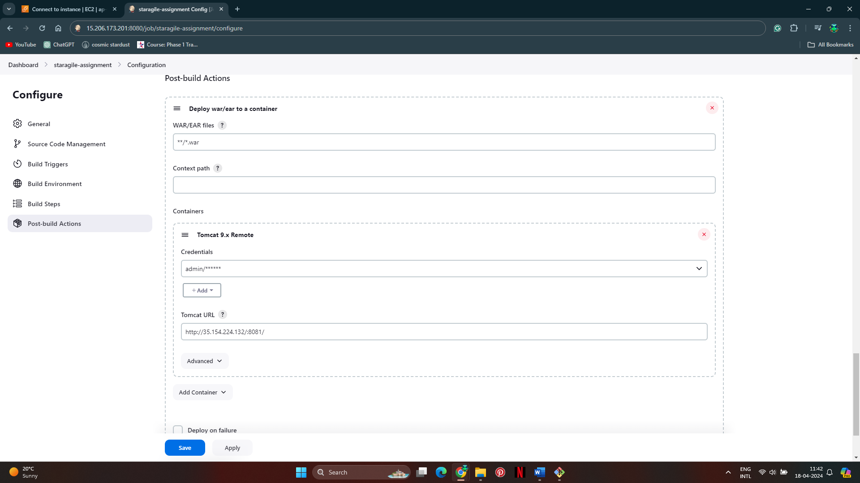

**Step 10. Build**

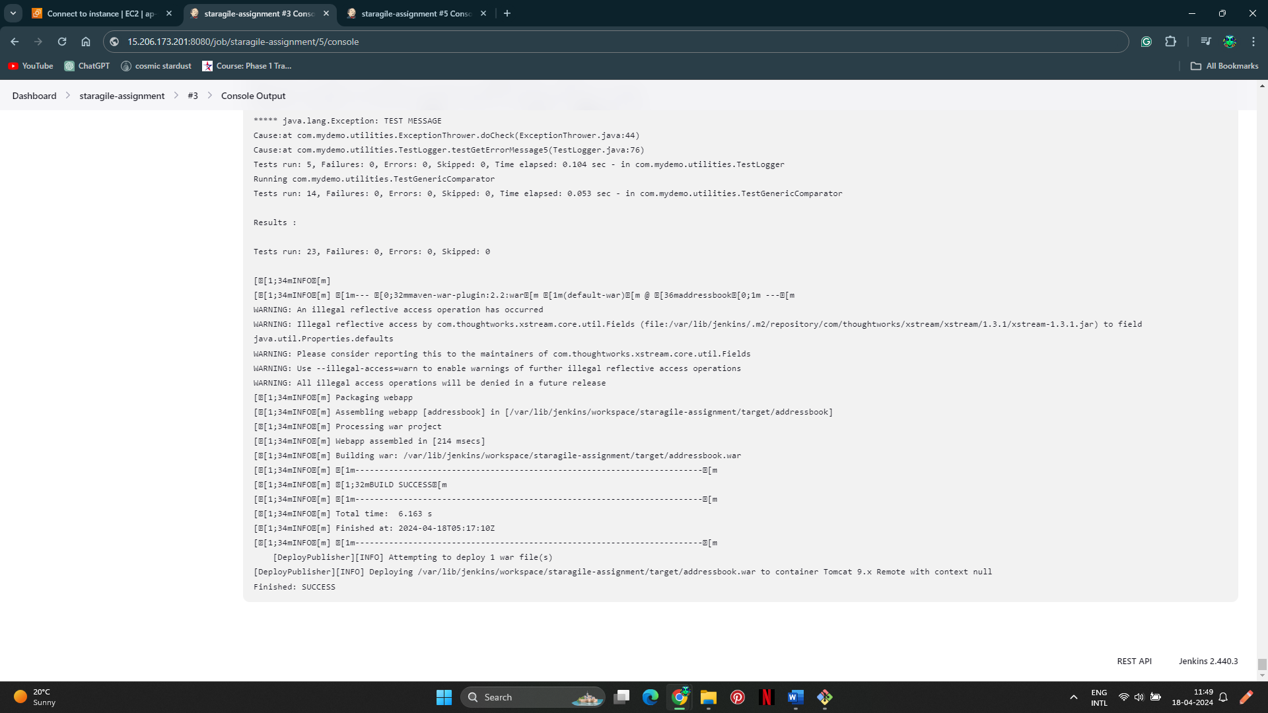

**Step 11: Verify Application After Successful Deployment**

